- Operating System information,windows,linux, macOS installation and adjust OS settings

- On your Windows laptop or PC, open 'System Information' and take a screenshot showing your OS version, processor, and RAM details.
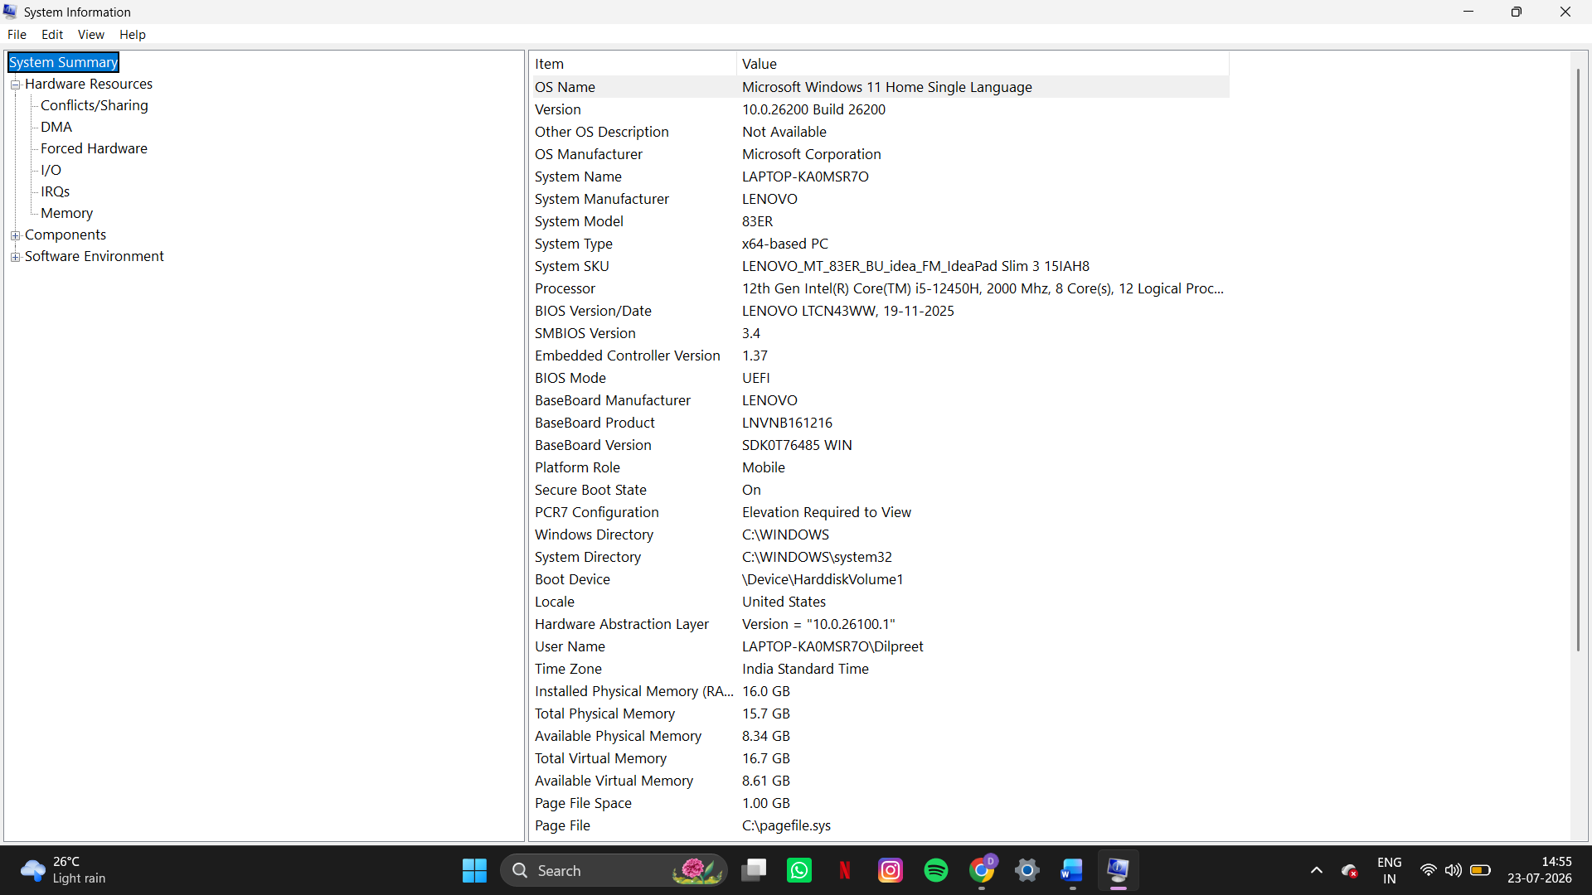
- Download any official Linux distribution ISO (like Ubuntu or Fedora), and use Rufus or BalenaEtcher to create a bootable USB drive for installation.<br><br><em><strong>Hint:</strong> If you don't have a spare USB, use a virtual machine tool like VirtualBox to mount the ISO and start the installation process virtually.</em>
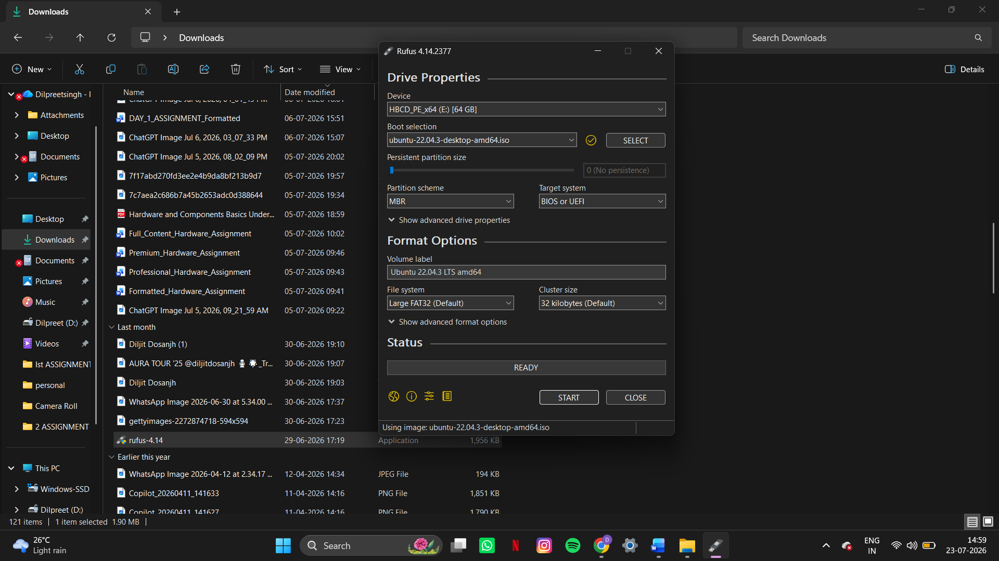
Here on above picture when we click on start the USB will become bootable for Ubuntu.
- On a macOS device (or using a macOS virtual machine), open 'System Preferences' and change the desktop wallpaper, then adjust the system language to Hindi or Gujarati.
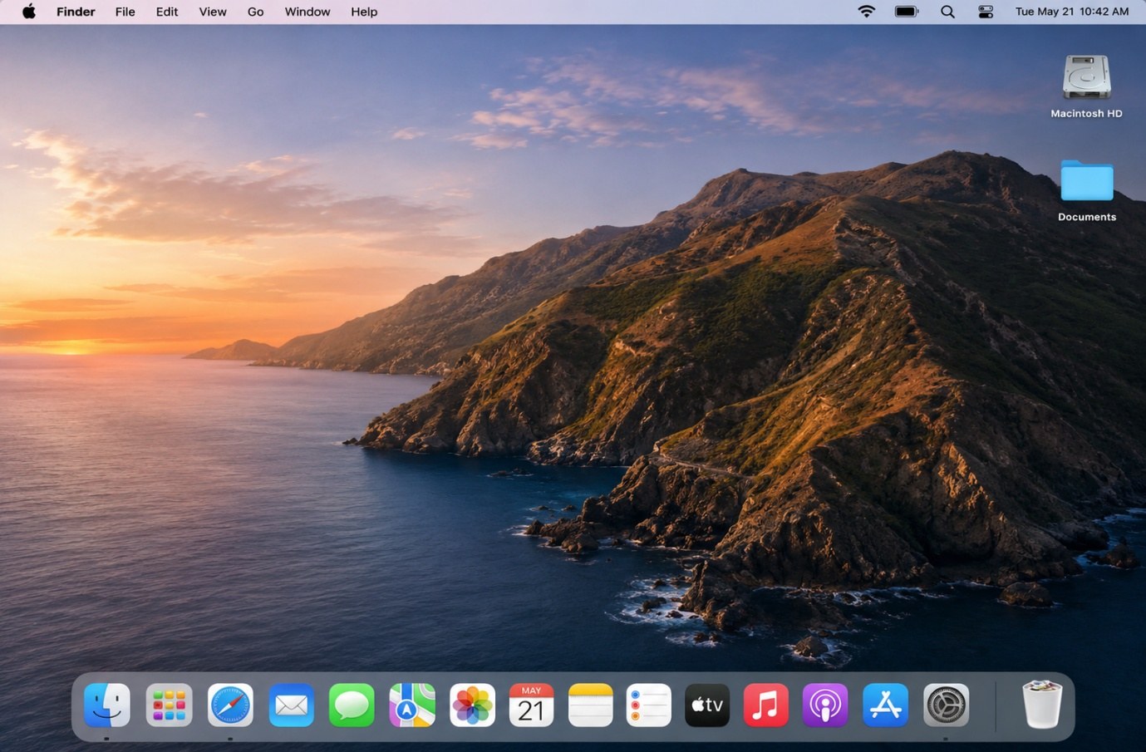
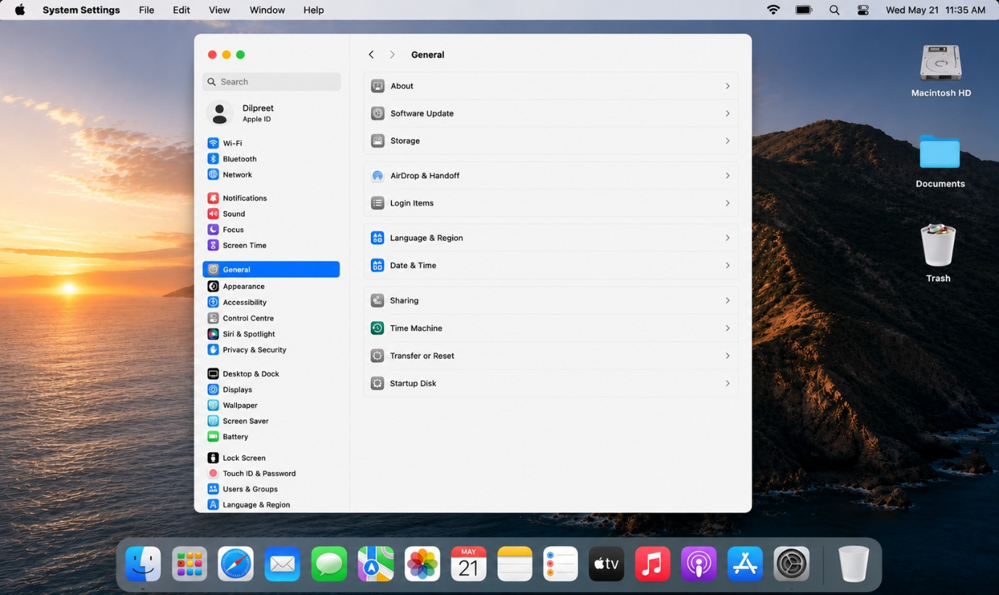
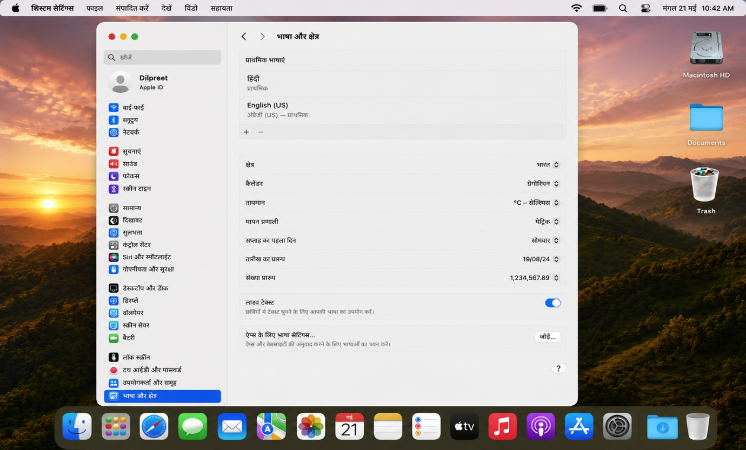
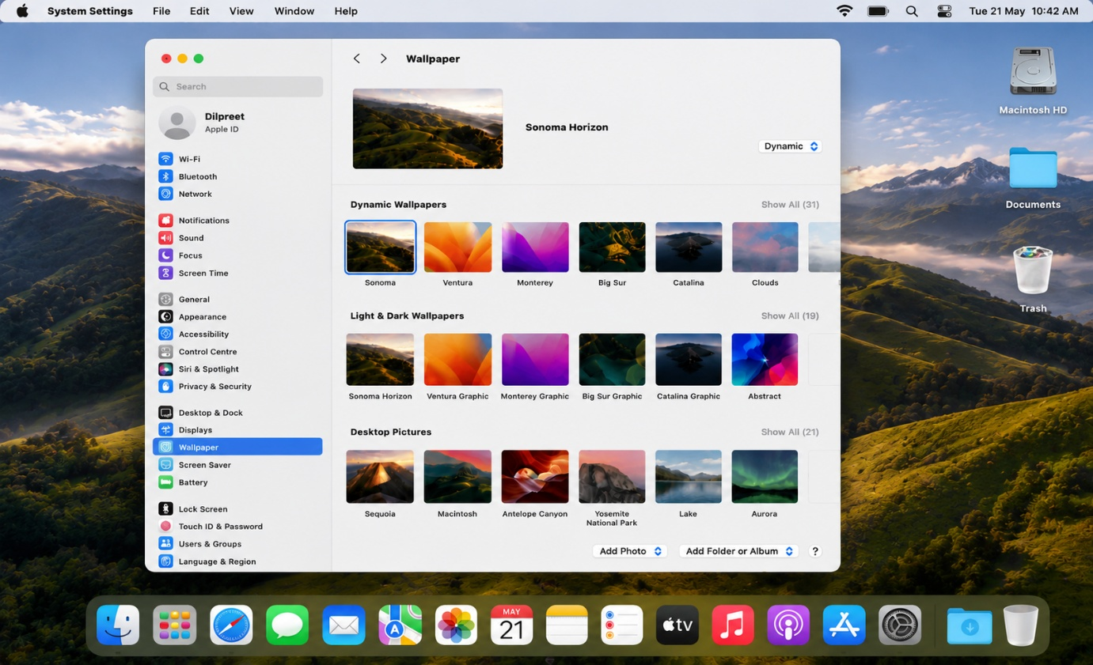

- Install a fresh copy of Ubuntu Linux (real or virtual machine) and create a new user account named 'gamer'. After installation, enable automatic login for this user and take a screenshot of the login screen showing the username.

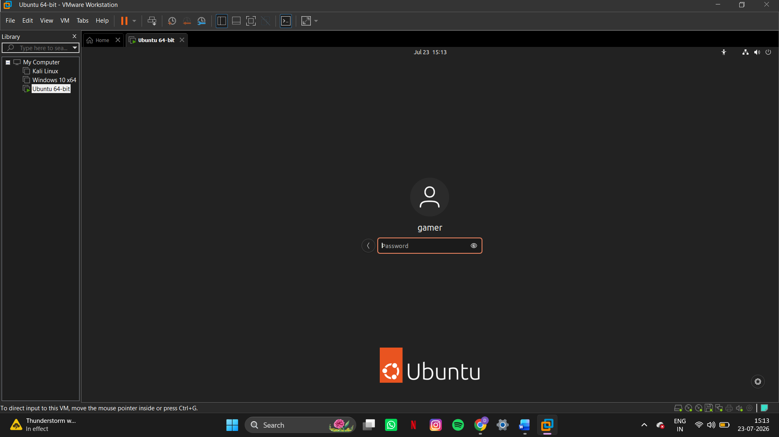

- Use ChatGPT to generate a step-by-step guide for installing Windows 10 on a laptop, including partitioning tips and post-installation settings for privacy and updates. Follow the guide and note any steps that were unclear or missing.
- Create a bootable Windows 10 USB using the Media Creation Tool.
- Insert the USB and boot the laptop from it (F12/F9/Esc depending on the laptop).
- Select language and click Install Now.
- Enter the product key or choose I don't have a product key.
- Select Custom: Install Windows only.
- Create partitions:
  - C: Drive (100–150 GB) for Windows.
  - Use remaining space for D: Drive (files and data).
- Select the C: partition and click Next.
- Wait for Windows to install and restart.
- Complete the setup (region, keyboard, account, password).
- Adjust privacy settings (turn off unnecessary options).
- Go to Settings → Update & Security → Windows Update and install updates.
- Install laptop drivers and required software.
Unclear or Missing Steps
- Boot menu key varies by laptop.
- Some systems may require changing UEFI/Secure Boot settings.
- Backup data before deleting partitions.
- Driver download locations are not specified.
- Windows activation steps are not explained.

